DRAFT
Mayo Creek Restoration Committee Accomplishments and Recommendations
12 February 2019
Introduction

The Mayo Creek Restoration Committee has studied the diked Mayo Creek (West Branch of Duck Creek) estuary since 2014, conducted office and field research, directed hydrodynamic modeling and held meetings with abutters and the general public. An interested audience has also been attending our open committee meetings. The Committee herewith presents its findings and recommendations to the Selectboard regarding the advisability and next steps in habitat restoration.
The Mayo Creek estuary formed thousands of years ago behind the Mayo Beach barrier spit, and is bordered on three sides by low-lying hills: Summit Hill, Taylor Farm and Holbrook Ridge. The original tidelands covered about 60 acres. Well drilling logs in and near the flood plain (Wellfleet Health Department; F. Cappello, personal communication) show several thick layers of clay, probably sediments deposited in glacial lakes during the last glacial retreat.

Tides and seawater were blocked from the back-barrier salt-marsh in 1909 when, to save money, the Town replaced a bridge across the original the 40-foot-wide inlet with a solid-fill dike (Commonwealth of Massachusetts 1909). This dike currently serves as a causeway connecting Commercial Street with the Wellfleet Marina and Kendrick Avenue. The only opening for water passage through the dike is a two-foot-diameter culvert intended to allow freshwater drainage to the harbor; a one-way valve at the seaward end of this culvert prevents nearly all saltwater inflow to the Mayo Creek estuary. About 15 acres of the original tidelands were filled with harbor dredged material in the early to mid-20th century; this fill enabled the development of Bakers Field, portions of the Harborside Village trailer park, and other low properties.

As a result of these man-made changes, the original back-barrier salt marsh is a highly degraded freshwater wetland. Original highly productive salt marsh grasses have been replaced by Phragmites australis (Common Reed), of much lower value to fish and wildlife, with freshwater wetland and upland shrubs and trees at higher elevations. As a result of negligible tidal flushing, the creek is chronically low in dissolved oxygen (APCC 2011), explaining the dearth of aquatic fauna, and high in nitrogen compounds and fecal coliform bacteria. Nitrogen loading to Wellfleet Harbor may be contributing to excessive algae blooms and oxygen depletion in the summer months. Fecal coliform is the microbial group used by public health officials to classify shellfish waters; as little as 14 CFU (colony-forming units) per 100 ml cause the closure of shellfish beds. Shellfish bed closures due to fecal coliform are common in the inner harbor and Duck Creek.

For about the past 10 years, the Town has investigated restoration of the estuary, initially through the Harbor Management Plan of 2006 and the Town Conservation Agent and, since 2014, through the Mayo Creek Restoration Committee. The MCRC comprises representatives from the Marina Advisory Committee, Conservation Commission, Shellfish Advisory Board, Natural Resource Advisory Board and Comprehensive Wastewater Management Committee. Over that period, the Committee has sought tidal-restoration alternatives that meet two criteria: 1) substantial salt-marsh restoration area within the Mayo Creek flood plain and 2) protection of surrounding infrastructure. This work has been guided by hydrodynamic modeling of physical alternatives by Woods Hole Group (WHG), under contract to the Town. This report summarizes the Committee’s current state of knowledge regarding: 1) justification for tidal restoration; 2) constraints on habitat restoration imposed by development; 3) an evaluation of management alternatives; and 4) recommendations for a physical restoration alternative (with preliminary cost estimate) and associated additional studies.

Justification for tidal restoration

Besides the water quality problems and salt-marsh vegetation loss mentioned above, the continued blockage of tides from Mayo Creek marshes also blocks sediment supply and limits the marsh’s ability to grow upward as sea level rises. In this way the storm-surge protection that this wetland would provide to shoreline properties is greatly diminished - a condition that will become increasingly threatening with climate warming and accelerating sea-level rise. It is important to note that the only storm-surge protection for low-lying properties around Mayo Creek is the Mayo barrier beach and marshlands, and not the dike at Commercial Street. The diked Mayo Creek flood plain is further threatened by prolonged flooding after major rain events, and an inevitable future overwash of Mayo Beach, by the undersized culvert under Commercial Street that provides the only outlet for water impounded in the diked wetland (WHG 2011).

Mayo Creek wetlands are located strategically along the groundwater flow path between Town Center, with many on-site wastewater systems and high groundwater nitrogen, and nitrogen-sensitive Wellfleet Harbor. Coastal wetlands, and especially regularly flooded salt marshes, can remove nitrogen before its discharge to surface waters. Diked and drained marshes lose much of their nitrogen-removal capacity. The importance of maintaining good water quality for the Harbor’s shellfish industry and for public recreation is obvious (Massachusetts Estuaries Project 2017). Restoration of the Mayo Creek estuary is part of the Town’s Comprehensive Wastewater Management Plan.

The diking and subsequent fill has eliminated about 60 acres of habitat for estuarine fish, shellfish, mammals and waterbirds, including the State-listed Diamondback Terrapin. Salt marshes serve as nurseries for both forage fish and for their larger predators like Bluefish, Striped Bass and Winter Flounder, all of commercial and recreational value.

Natural salt marshes store carbon faster and retain it longer than any other ecosystem on the planet; they are net sinks for atmospheric carbon dioxide. In contrast, diked and freshened marshes, like tide-restricted Mayo Creek, have been found to be net sources of greenhouse gases including highly heat-absorbing methane (Drake et al. 2015).

Despite purported mosquito control, historic salt marsh diking has been shown to increase mosquito breeding by degrading water quality and habitat for predatory fish and reducing tidal flushing (Portnoy 1984, Portnoy et al. 2016). For this reason, the Cape Cod Mosquito Control Project supports tidal restoration in Mayo Creek and similarly altered coastal wetlands.

Finally, tidal restoration in Mayo Creek will greatly increase the system’s tidal volume (WHG 2011, 2016). This may result in increased flow velocities within the North Channel of the marina, currently choked with fine-grained anaerobic muck (“black mayonnaise”). Increased flow velocities (especially during ebb tides) should scour (re-suspend) some of this fine sediment. This may reduce the need for future dredging in the channel north of the marina pier. Harbor modeling is required to verify this hypothesis.

Infrastructure limiting habitat restoration
The Committee determined the following through Health Department record searches, consultation with scientific and engineering experts, literature research, field work and extensive meetings and interviews with project abutters. Technical reports that formed the basis of our conclusions are available upon request, and will be submitted to the Town for inclusion on its website. Note that elevations are all relative to NAVD88:
1. After 109 years of tidal restriction, the Mayo Creek estuary suffers from dissolved oxygen stress, high nitrogen and fecal coliform pollution and the invasion of non-native Phragmites australis and upland shrubs and trees, which have displaced native salt-marsh plants (APCC 2011).
2. Since diking, creek channels upstream of Commercial Street have filled with sediment.
3. Existing tidal range in diked Mayo Creek is only 1.7 ft, as opposed to the 10-ft range in Wellfleet Harbor; the former results in negligible marsh inundation (WHG 2011; see appended plot of relative elevations).
4. Existing mean tide level in Mayo Creek is -1.7 ft; it is -0.42 in the Harbor (WHG 2011).
5. Land surface of developed fill is generally at elevation 2-4 ft (Outermost Land Survey data), at least a foot below the height of average high tide in the Harbor.
6. Development within and around the diked flood plain since 1909 severely limits the Town’s restoration options because of low-lying structures and infra-structure.

These limits are highlighted below:

Property Elevations.
7. The land surface at the lowest dwelling within the diked flood plain is at an elevation of about 1.3 ft (Outermost Land Survey); note that high tides in unrestricted Wellfleet Harbor regularly reach about 5 ft. Respecting this constraint, limits the maxi,umm marsh restoration to 20 acres+.

Wastewater Systems.
8. The lowest sub-surface wastewater disposal system in or near the flood plain is at elevation 6.8 ft (Outermost Land Survey data). This barely meets the minimal separation distance to groundwater mandated by the health code. Any increase in mean tide level in Mayo Creek could reduce this separation further. All other wastewater disposal systems are too high (Outermost Land Survey) to be affected by the recommended (see below, WHG 2016) degree of Mayo Creek tidal restoration.
Hydrology science (L.Martin, personal communication, 2016) shows that maintaining ground water levels requires maintaining the current mean tidal elevation in the creek. In order to achieve meaningful restoration, a dredging of the current stream bed is required.
This has the added benefit of restoring a natural marsh connection to the harbor: real salt marshes do not end in waterfalls.
9. Shallow groundwater in developed fill is well above and unaffected by water levels in Mayo Creek.; it does, however, fluctuate with the much larger Wellfleet Harbor tides (MCRC water table monitoring 2015).

Drinking Water
10. The most vulnerable private supplies are located in the low ground from the foot of Holbrook west along Kendrick. Most of these are now on Town water. We believe that the others are also low risk (for reasons see below). However, if necessary, well relocation or agreements to supply Town water are possible.
Neither of these options for the public water supply at HVCC are practical. We took the initiative to meet privately (*) with the HVCC technical representative and two hydrology consultants to discuss specific issues at HVCC. One outcome of this meeting was a suggestion for a “pumping test” to further clarify the risks. An outline of the test protocol has been completed.
(* Thanks to Dave Bennet of Bennett Associates for hosting this meeting.)
11. Private water-supply wells around Mayo Creek should not be affected by tidal restoration because of their depth, the thickness of the freshwater lens and, in some cases, intervening layers of impermeable clay (Personal communications, Cape Cod Commission and Horsley Witten hydrologists 2018; see Martin 2019 for general hydrogeology and surface water/groundwater relationships in outer Cape estuaries). Hydrologic studies by USGS (J.A.Colman & J.P.Masterson, USGS, 2007) confirm a flow of groundwater from the hills surrounding the Mayo Creek marsh to the marsh basin. This flow – which includes fresh groundwater under the old marsh – will significantly impede any diffusion of salt towards wells.

Other Issues
12. Tidal restoration of Mayo Creek is supported by the Cape Cod Mosquito Control Project because of expected improvements in tidal flushing and reductions in breeding habitat (letter of August 20 2014).
13. The Massachusetts Division of Fisheries and Wildlife has determined that there are no endangered species that would be affected by restoration in Mayo Creek (letter of June 2 2008).

An evaluation of tidal-restoration alternatives
For all of the reasons described above, the Committee concludes that no action, i.e. continued diking of Mayo Creek, is contrary to shared public interests and will allow adverse effects, e.g. poor water-quality, shoaled channels, lost fish, shellfish and wildlife habitat, reduced storm-surge protection, to worsen over time.
Therefore, alternatives for tidal restoration, given environmental objectives and social constraints, were investigated with a hydrodynamic model.
The Committee determined the following through hydrodynamic modeling by Woods Hole Group:
1. Simple removal of the current duckbill does not provide adequate tidal elevations in a restored marsh and is not recommended. (WHG 2011).
2. Despite the severe limits that past development has placed on the Town’s options for tidal restoration:
Replacement of the Commercial Street culvert with an enlarged culvert (e.g. 6 X 7 ft) with active control, along with excavation of the upstream creek channel, can yield over 20 acres of estuarine habitat restoration and over five feet of tidal range (as opposed to existing 1.7 ft). Importantly, increased tidal range is achieved by 2-ft higher high tides along with 2-ft lower low tides (WHG 2016). These tidal ranges keep the important mean tide levels in the creek unchanged.
The Committee believes that this can be accomplished without harm to adjacent development including the lowest structures, wastewater systems and probably supply wells. This alternative should also improve freshwater drainage during low tides and in the event of an overwash of the Mayo barrier beach (WHG 2011, 2016).
A very preliminary cost range for the large and adjustable culvert is $2-4 million (N.Wiberg, personal communication).
In the appendix are: an aerial view of the marsh with contours showing the maximum extent of restoration under the constraints we have outlined and a photo of tide gates that serve the purpose of the restoration.

Committee recommendations for future actions:
At least 20 acres of salt-marsh restoration above Commercial Street is feasible without harming adjacent development and furthers public interests associated with estuarine habitat and water quality.
Tidal restoration should be incremental, using an adjustable culvert gate (WHG 2016), and ecosystem response carefully monitored with emphasis on tide heights and groundwater and surface water quality.
Should the Selectboard agree with the recommendations the following actions are recommended:
1. The Town should hire a consultant knowledgeable in permitting to review the committees work and recommend an action plan to develop necessary permits;
2. Contract for an initial engineering design of control gates to replace the current duckbill at the Commercial Street culvert. Key design criteria include:
> adequately praise tidal gate control to ensure no flooding of private structures;
> flexibility to respond to major storm events, either to avoid flooding or to ensure rapid marsh drainage, according to circumstance. Implied in this is that Mayo Creek tidal gate control would need to be part of a Town Emergency Management Plan.
3. Prepare and implement a pre-restoration monitoring of creek tides, groundwater levels and - with permissions - drinking water quality. Some additional surveying maybe needed to verify critical elevations and marsh contours.

Literature cited

Association to Preserve Cape Cod. 2011. Report on 2010 Mayo Creek Salt Marsh Pre-restoration Monitoring.

Colman, J.A., Masterson, J.P, Monitoring Groundwater Quality in Coastal Ecosystems, USGS
2007-1149
Commonwealth of Massachusetts. Board of Harbor and Land Commissioners. Chapter 91 license to build bulkhead, culvert and tidegate and to fill soild at Mayo Beach bridge. 7 June 1909.
Drake, K., H. Halifax, S. Adamowicz, & C. Craft. 2015. Carbon sequestration in tidal salt marshes of the northeast United States. Environmental Management 56:998-1008.
Martin, L. 2019. Evaluation of the Potential for Private, Domestic Wells to be Affected by Restoration of Tidal Flow in the Herring River Basin, Cape Cod, Massachusetts. Report to the Herring River Restoration Committee.
Massachusetts Estuaries Project. 2017. Linked Watershed-Embayment Model to Determine Critical Nitrogen Loading Thresholds for the Wellfleet Harbor Embayment System Town of Wellfleet, Massachusetts.
Portnoy, J.W. 1984. Salt marsh diking and nuisance mosquito production on Cape Cod, Massachusetts. J. Amer. Mosq. Cont. Assoc. 44:560-564.
Portnoy, J., A. Iacuessa, B. Brennessel. 2016. Tidal Water: A History of Wellfleet’s Herring River.
Woods Hole Group. 2011. Final Mayo Creek Salt Marsh Restoration Feasibility Study and Hydrodynamic Modeling.
Woods Hole Group (WHG). 2016. Mayo Creek Salt Marsh Restoration: Culvert Design Alternatives

Acknowledgements. We thank Coastal America and the MassBays program for financial support. Assistance and support from Town staff, committees and APCC has also been invaluable.

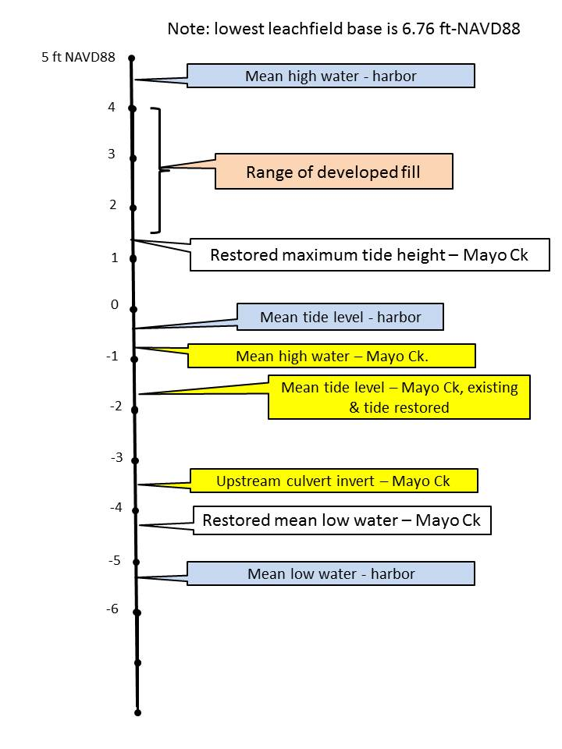
Critical elevations in diked Mayo Creek.

Contours in restored Mayo Creek
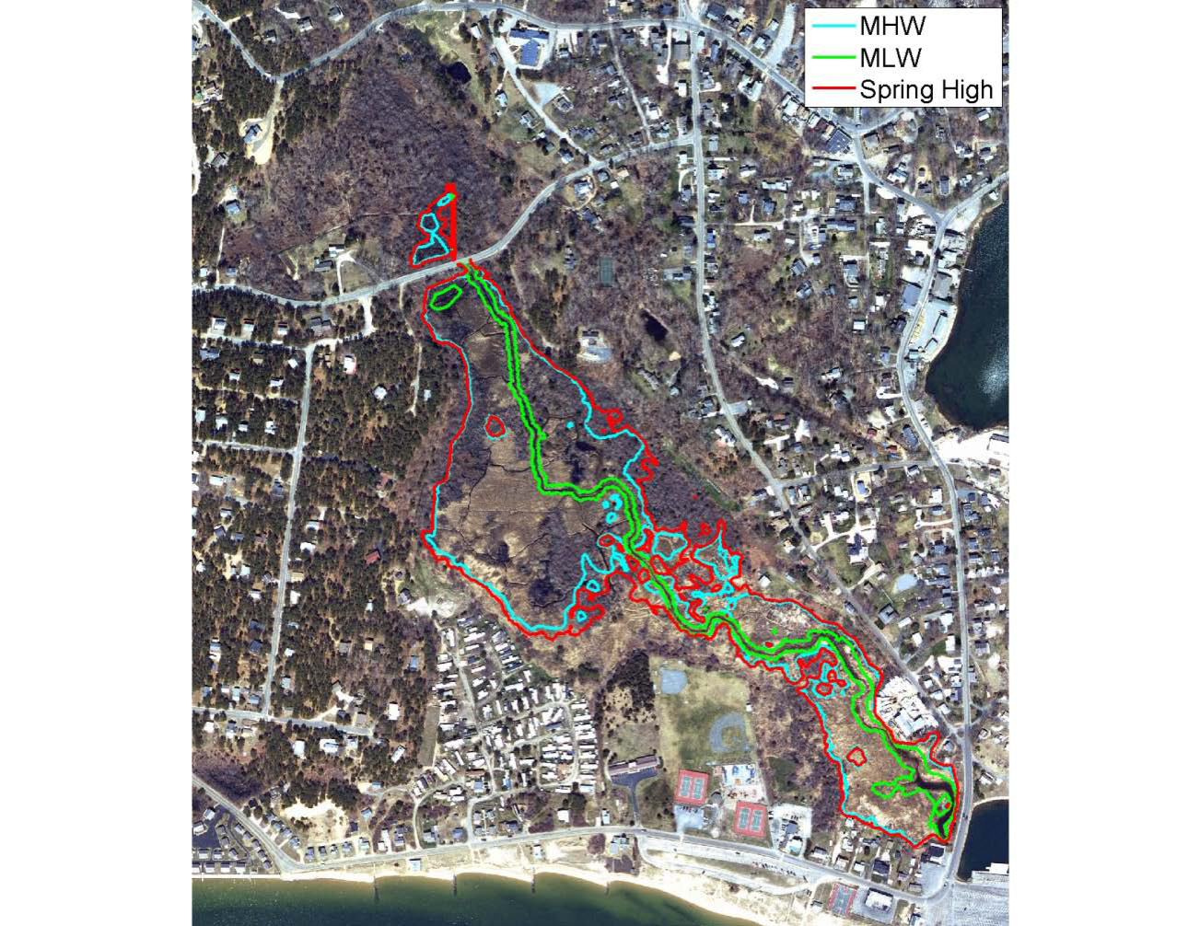

Conceptual Tide Gates – Golden Harvest GH-50

